**Appendix 1**

The following pages contain data from the reference materials (Harvard 91500 and Plešovice) analyzed during this study. The mean age for 186 analyses of Harvard 91500 was 1062 ± 4.4 Ma. The mean age for 180 analyses of Plešovice was 335.1 ± 1.2 Ma. For an Excel spreadsheet of the data, please contact Stephen Hughes (kstephenhughes@gmail.com).

Concordia plot for 186 analyses of Harvard 91500 standard:

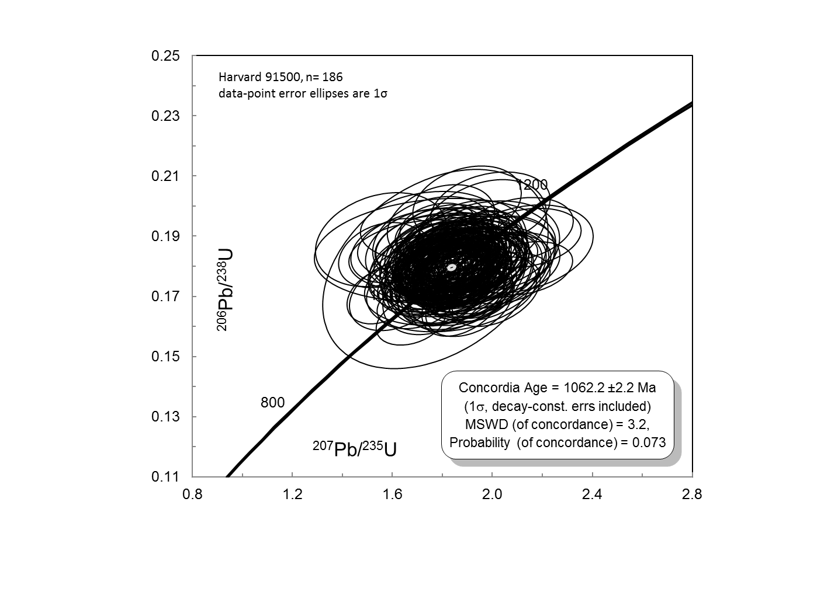

Concordia plot for 180 analyses of Plešovice standard:

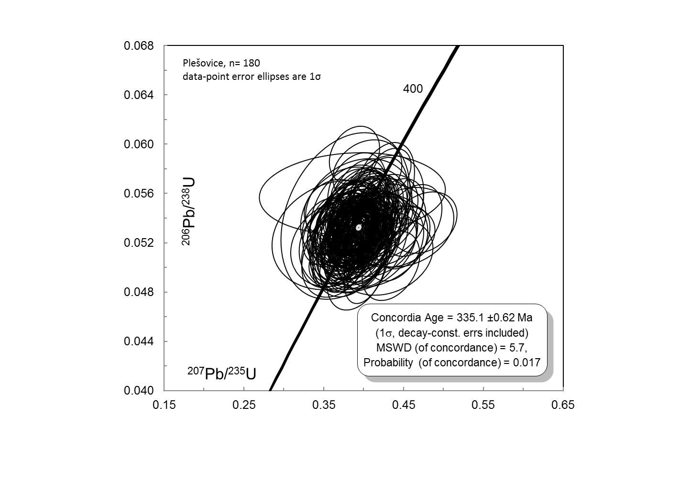

Standard Harvard 91500:



Standard Harvard 91500 continued:



Standard Harvard 91500 continued:



Standard Harvard 91500 continued:



Standard Plešovice:



Standard Plešovice continued:



Standard Plešovice continued:



Standard Plešovice continued:

